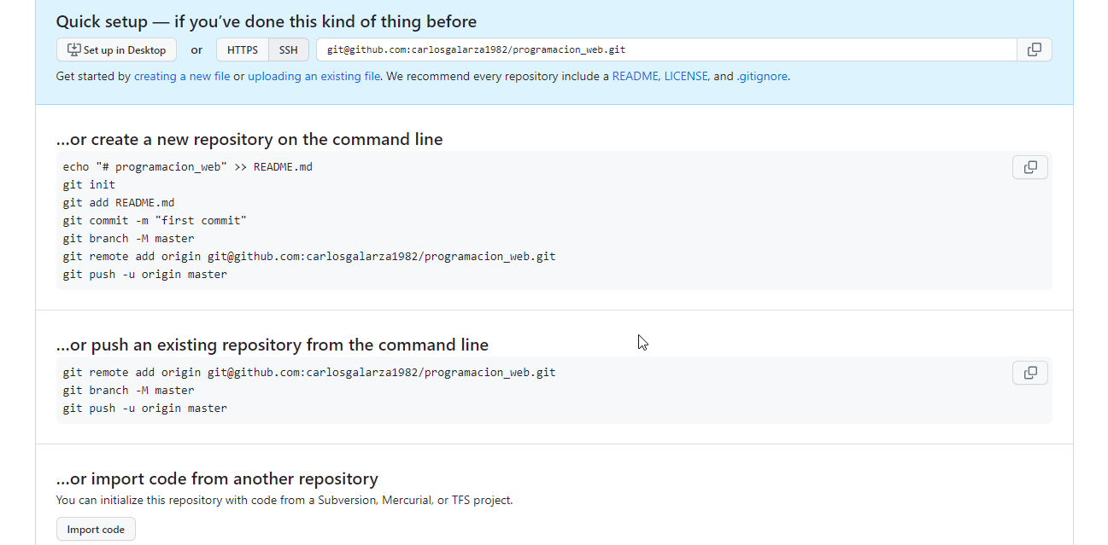

**…or create a new repository on the command line**

echo "# programacion_web" >> README.md

git init

git add README.md

git commit -m "first commit"

git branch -M master

git remote add origin git@github.com:carlosgalarza1982/programacion_web.git

git push -u origin master

**…or push an existing repository from the command line**

git remote add origin git@github.com:carlosgalarza1982/programacion_web.git

git branch -M master

git push -u origin master

**…or import code from another repository**

You can initialize this repository with code from a Subversion, Mercurial, or TFS project.

Esta parte para la entrega de tareas:

